Question 1 – Doctor Shift Scheduling using Backtracking Search

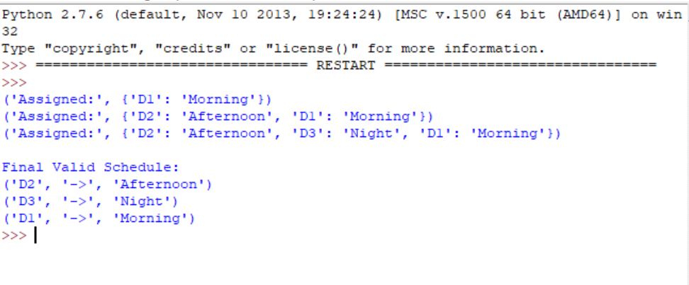Question 2- Robot Grid Navigation using Breadth First Search

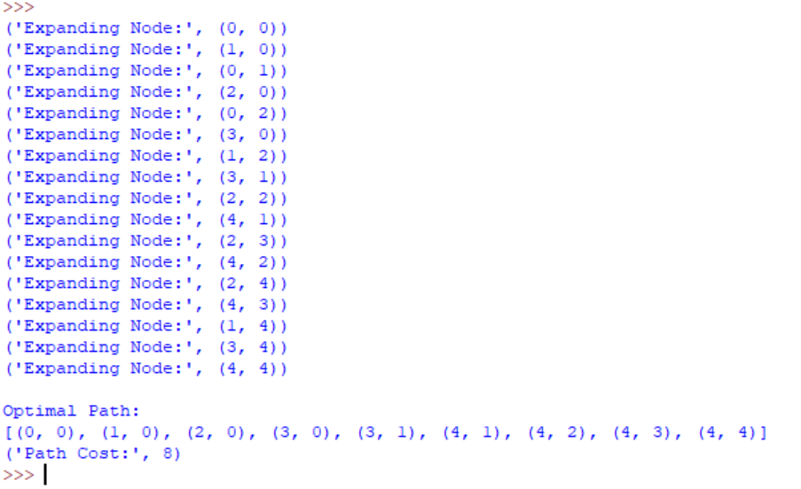

Question 3 – Autonomous Rescue Robot using Uniform Cost Search

